**Subject:** Smart Monitoring & Automation Solutions – Upgrade Today!

**Header:** Advance Your Operations with Wireless Sensor Networks (WSN) – Efficiency at Your Fingertips!

**Body:**

**1. Wireless Door Sensor Node**  
Monitor door status instantly with our small, wireless door sensor node. Enjoy seamless facility management and enhanced security with real-time data sent to the cloud.  
**✨ Key Features:**

* Real-time door status updates (open/close)
* 3-year battery life
* PCB antenna and ultra-low power consumption
* Ideal for smart buildings & industrial monitoringA white device with a light on it

  Description automatically generated with medium confidence

**2. Wireless Humidity & Temperature Sensor**  
Track environmental conditions with precision. Perfect for cold storage, warehouses, and HVAC systems.  
**✨ Key Features:**

* Humidity (0-100%) and temperature (-40°C to +125°C)
* 1 km wireless range (line of sight)
* Ultra-low power with long battery life
* Real-time data sent directly to the cloud

**3. Wireless Load Cell Sensor**  
Accurate load measurement for LPG cylinders, industrial gauges, and fitness equipment.  
**✨ Key Features:**

* Measures up to 1000 Kg with ±0.3 accuracy
* Configurable reporting intervals
* Long battery life with minimal power consumption
* Operates in India’s license-free band (865-867 MHz)

**4. PT100 Wireless Temperature Sensor**  
Ensure high-temperature accuracy for industrial applications. Ideal for furnaces, cold storage, and warehouses.  
**✨ Key Features:**

* Temperature range: -200°C to +550°C
* 1 km wireless range with dipole antenna
* Configurable reporting intervals
* FCC/ETSI certified

**5. Wireless PIR Motion Sensor**  
Enhance security with real-time motion detection for alarms and light switches.  
**✨ Key Features:**

* 5m detection range
* 94° horizontal, 82° vertical detection angle
* Ultra-low power consumption
* Ideal for security systems and smart homes

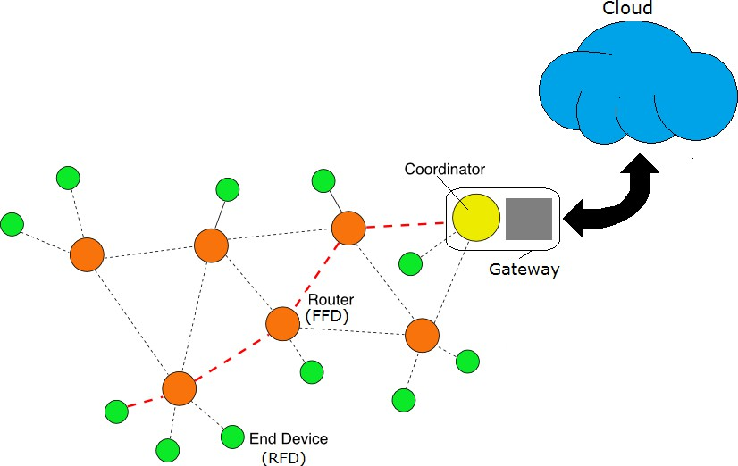

**Act Now!**  
Explore our full range of WSN products including cold chain monitors, emergency buttons, and weather stations. Contact us today for a live demo or more information.

**CTA:** [Discover More] or [Book a Demo]

**Subject:** Unlock Smart Monitoring – Wireless Sensor Networks for Every Need!

**Header:** Real-Time Monitoring & Automation for Cold Chain, Water, and Environment

**4. Wireless Cold Chain Monitor**  
Ensure the integrity of your cold chain with real-time temperature and humidity monitoring. Ideal for warehouses, mobile refrigeration, and iceboxes.  
**✨ Key Features:**

* Monitor temperatures from -50°C to +125°C
* 1 km wireless range
* 64 nodes supported per gateway
* Ultra-low power, long battery life

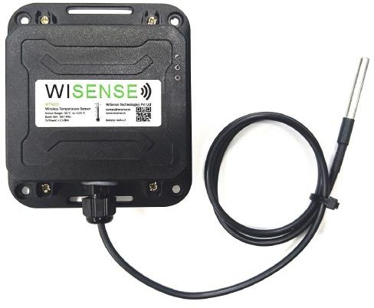

**5. Low Profile Wireless Temperature Tag**  
Track indoor temperatures seamlessly. Perfect for pharmaceutical monitoring and cold storage.  
**✨ Key Features:**

* Measures -20°C to +50°C
* Compact design, long battery life
* 100 m wireless range
* Real-time data reporting

**6. Wireless Solar Powered Sensor Node**  
Power your sensor networks with sustainable solar energy. Reliable for outdoor electronics and sensor nodes.  
**✨ Key Features:**

* Auto switch to battery backup
* Monitors voltage, current, and battery status
* Up to 2A charging capacity
* Supports I2C, UART, SPI interfaces

**7. Wireless Water Metering Sensor**  
Optimize water usage with real-time flow monitoring. Perfect for domestic and industrial applications.  
**✨ Key Features:**

* Periodic flow data reporting
* Reduces wastage, enables smart billing
* Operates in license-free band
* Long battery life, configurable intervals

**8. Wireless Weather Station**  
Monitor environmental conditions with accuracy. Ideal for rain measurement and ambient monitoring.  
**✨ Key Features:**

* Measures temperature, light, and pressure
* Weather-resistant, long-range dipole antenna
* IP65 rated for durability

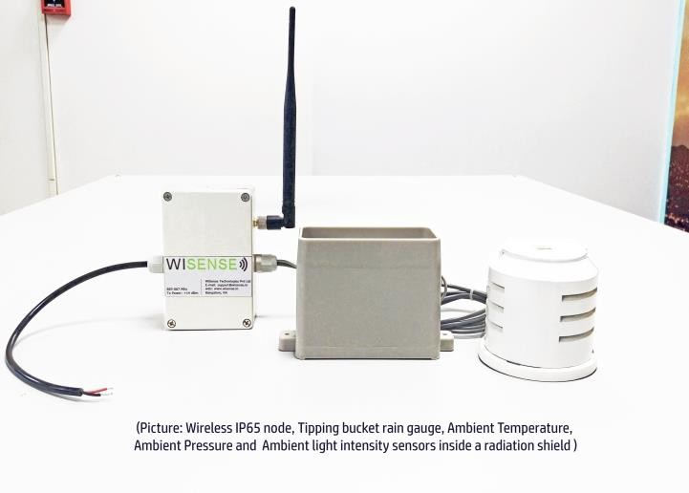

**Product Applications**

**Act Now!**  
Experience seamless monitoring and automation. Contact us today for more details or to schedule a demo.

**CTA:** [Learn More] or [Get in Touch]